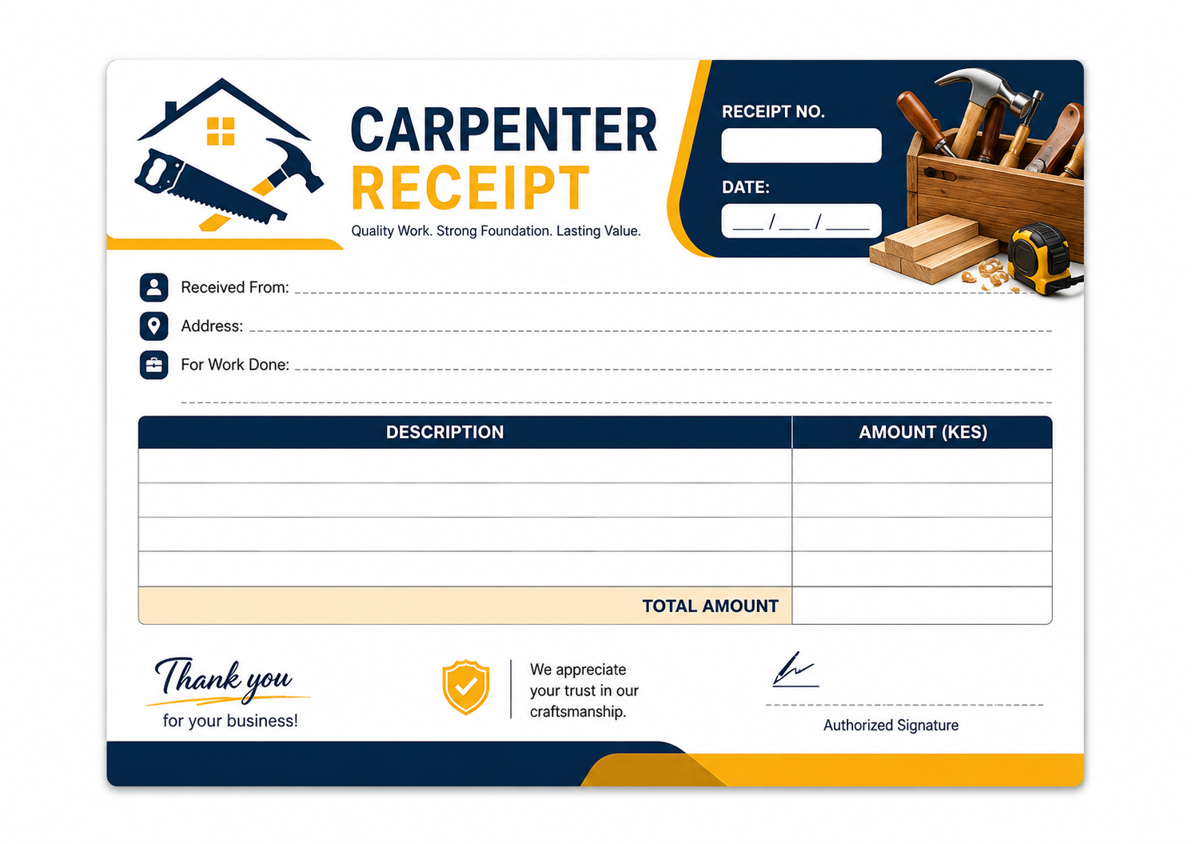
EDITABLE RECEIPT FIELDS
Receipt No. | __________________ | Date | __________________
Received From | __________________ | Phone | __________________
Work Done | ____________________________ | Amount (KES) | ____________
Professional • Colorful • Print-ready • Quarter-A4 size

